**Group Assignment Report for**

**“Time Series Forecasting”**



**SUBMITTED TO: GREAT LAKES INSTIUTE OF MANAGEMENT**

*In partial fulfilment of the requirements for the award of degree of*

*PGP – Business Analytics and Business Intelligence*

|  |  |
| --- | --- |
| **Submitted by: Group 10** | **Student ID** |
|  |  |
| Thokchom JoychandraSingh | E8DLVOV0YE |
| Saurav Banerjee | UMD99XSVGR |
| Raunak Rudra | N7OLAWANQZ |
| Prakash Palanisamy | L3SEDQPKOF |
| Shraddha Chaudhari | BM7D62U49L |



**PGP-BABI 2019-20**

# ****Souvenir data Sales Forecasting****

**Problem Statement:**

Sales of souvenir data have been provided in the fancy.txt file.

Part A)

Using the Winter-Holts methods and model the data and predict for the next 5 years.

Your submission should contain the complete modeling steps with explanations.

Include pictures and R-code where applicable.

Part B)

Using the ARIMA method models the data and predict for the next 5 years. Your

submissions should contain the complete modeling steps with explanations. Include

pictures and R-code where applicable.

**1.1 BasicData Structure:**

The given fancy data set has sales data from January 1987 to December 1993.There seems to be no data missing in the overall observation so there will not be any holes while creating the time series.



**FIG: Variables in the fancy data set**



**FIG: Sample data in the fancy data set**

**Creating the time series for the data**

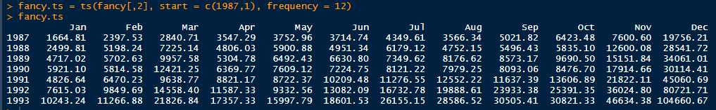

**1.2 Exploratory Data Analysis on the Time Series:** Visualizing the whole data, dividing the time series data into different components and plotting the different components individually.

On plotting the Time series we see an upward trend in general and there seems to be seasonality in the data.

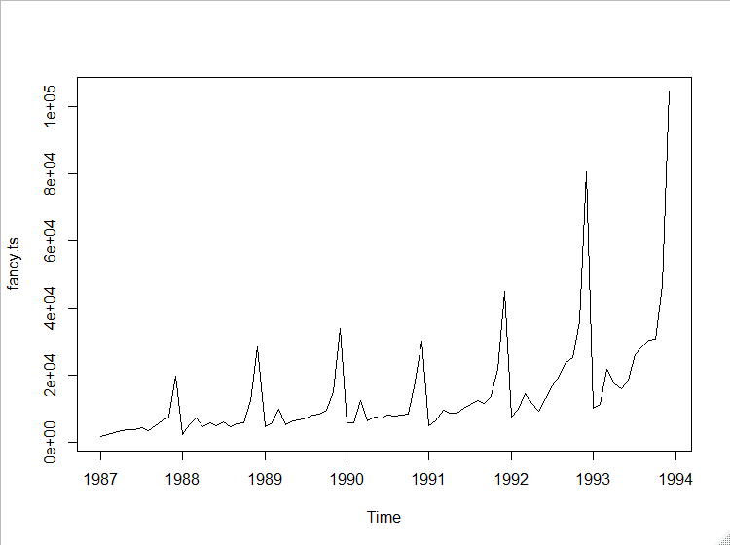

Decomposed original time series into 12 monthly time series and looking at data from month over month perspective. For every month over years we see an upward trend in general barring little randomness. There is slight increase in average number of sales for month of March and then since July there is an increase in sales which is peaking in month of December (average sales closing to 50,000). This suggests strong seasonality towards the holiday season.

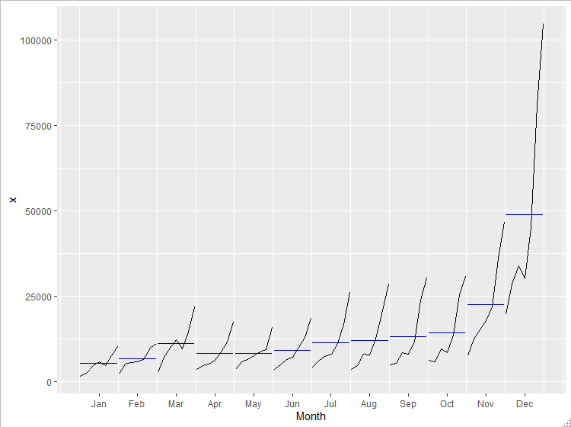

As the year goes by the increase in number of sales seems to be going up in multiplicative way. Also the plot suggests that there is some irregular component present in time series as well. There was some drop in year 1990

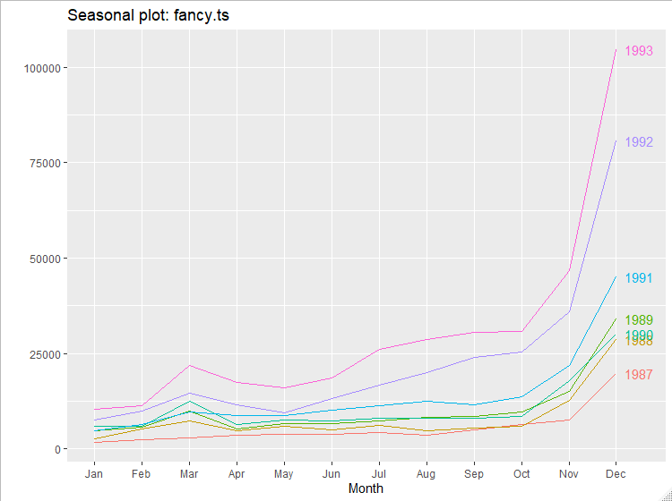

Decompose and plot the time series in Trend, Seasonality and random part based on additive approach



We observe that there is an upward trend for moving averages and decomposing asserts our assumption that there is strong seasonality towards year end when the seasonal component is positive. The random component indicates that we were over estimating the sale in December from '87 to '90 and then underestimated the sales in 1992.

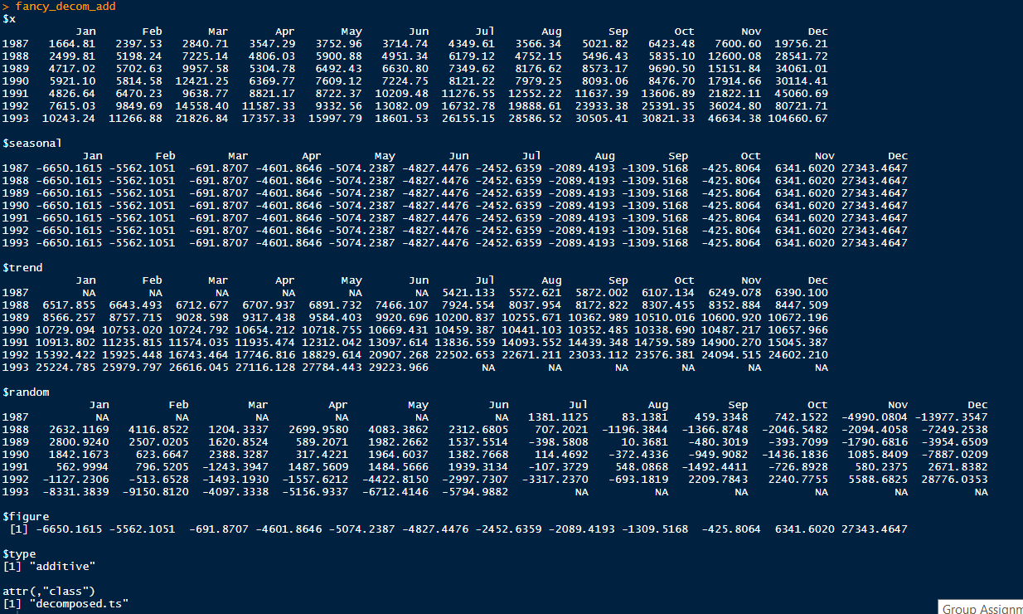

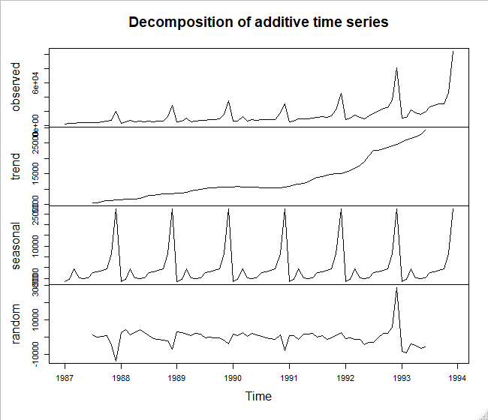

Decompose and plot the time series in Trend, Seasonality and random part based on multiplicative approach



We observe that there is an upward trend for moving averages and decomposing asserts our assumption that there is strong seasonality towards year end when the seasonal component is positive. This decomposition also looks much fitted to the time series as the randomness is distributed between range 0.7 to 1.3. The random component indicates that it is doing a better job in estimating the sales for November and December and there doesn't seem to be a trend in multiplicative. The seasonality effect is also better represented as percentages in case of multiplicative time series.

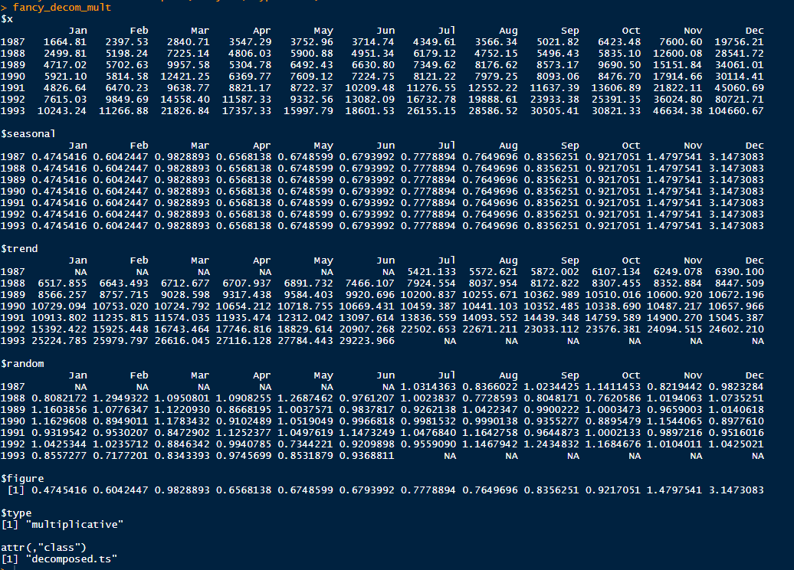

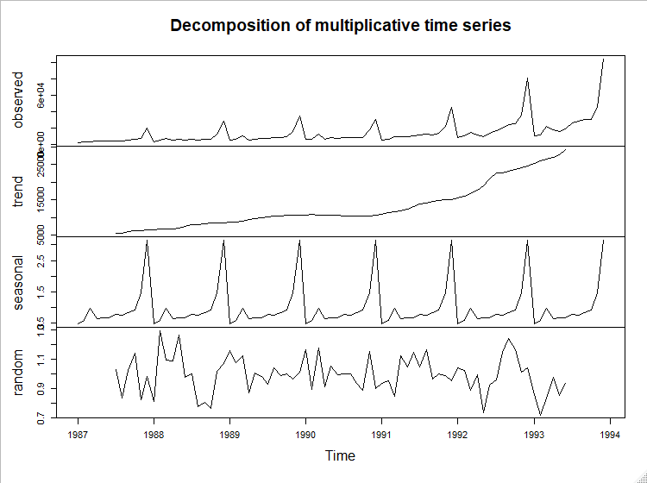

**1.3 Time series stationarity check**

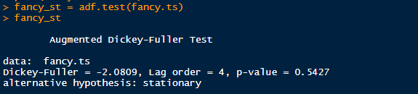

p-value of 0.5427 suggests that time series is not stationary and we will have to look at the change of sales to see if that is stationary.

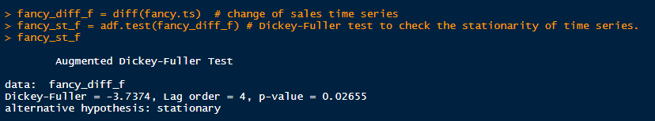

p-value is less that 0.05 which suggests that change of sales time series is stationary, plotting the change of sales times series to visualize and validate.

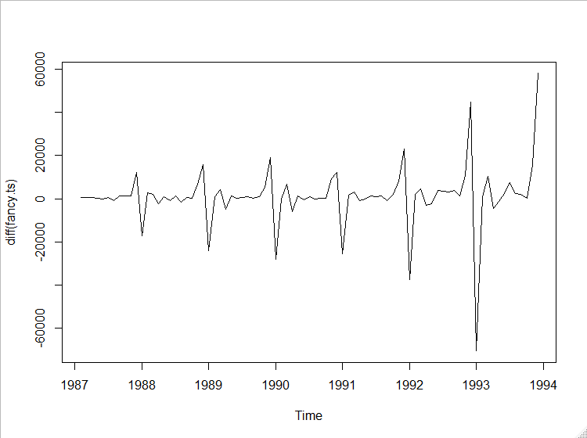

**2.1 Holt Winter Model Creation**

**2.1.1 Basic Additive model**

Since there is both trend and seasonality in the time series we will be using all the 3 smoothening parameters alpha, beta & gamma and use tripe smoothening method.

Creating a basic holt winter's model with additive method but the default horizon is only 2 years.

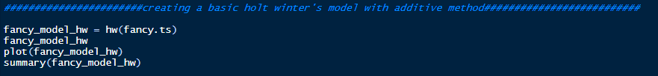

> summary(fancy_model_hw)

Forecast method: Holt-Winters' additive method

Model Information:

Holt-Winters' additive method

Call:

hw(y = fancy.ts)

Smoothing parameters:

alpha = 0.0357

beta = 0.013

gamma = 0.9643

Initial states:

l = 6859.487

b = 120.8924

s = 29935.7 6336.533 -421.9194 -1308.719 -2089.593 -2451.815

-4829.119 -5074.125 -4601.976 -691.2885 -5561.374 -9242.308

sigma: 5950.576

AIC AICc BIC

1848.568 1857.840 1889.891

Error measures:

ME RMSE MAE MPE MAPE MASE ACF1

Training set 657.8767 5353.944 3305.795 1.884505 30.16858 0.7470081 0.2826992

Forecasts:

Point Forecast Lo 80 Hi 80 Lo 95 Hi 95

Jan 1994 19369.61 11743.64 26995.58 7706.697 31032.52

Feb 1994 20473.51 12838.49 28108.54 8796.753 32150.27

Mar 1994 31001.99 23352.44 38651.54 19303.017 42700.96

Apr 1994 26587.12 18916.33 34257.92 14855.650 38318.60

May 1994 25307.71 17607.70 33007.72 13531.564 37083.85

Jun 1994 28082.27 20343.91 35820.63 16247.471 39917.07

Jul 1994 35730.72 27943.73 43517.71 23821.541 47639.89

Aug 1994 38300.05 30453.08 46147.02 26299.141 50300.96

Sep 1994 40453.78 32534.49 48373.08 28342.268 52565.30

Oct 1994 41087.54 33082.69 49092.40 28845.173 53329.91

Nov 1994 57079.50 48975.05 65183.96 44684.805 69474.20

Dec 1994 114758.50 106539.71 122977.30 102188.940 127328.06

Jan 1995 29467.71 17412.58 41522.84 11030.983 47904.43

Feb 1995 30571.61 18415.32 42727.90 11980.168 49163.05

Mar 1995 41100.09 28830.37 53369.80 22335.179 59864.99

Apr 1995 36685.22 24289.36 49081.08 17727.394 55643.05

May 1995 35405.81 22870.68 47940.93 16234.985 54576.63

Jun 1995 38180.37 25492.50 50868.24 18775.950 57584.79

Jul 1995 45828.81 32974.44 58683.19 26169.752 65487.88

Aug 1995 48398.15 35363.28 61433.01 28463.041 68333.26

Sep 1995 50551.88 37322.35 63781.41 30319.060 70784.70

Oct 1995 51185.64 37747.16 64624.12 30633.256 71738.02

Nov 1995 67177.60 53515.81 80839.39 46283.699 88071.50

Dec 1995 124856.60 110957.13 138756.07 103599.192 146114.01

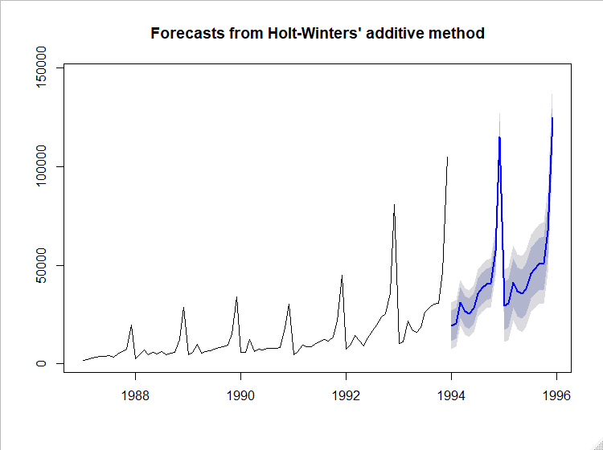

Since we need to forecast for 5 years increasing the horizon to 5 years

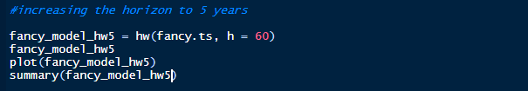

summary(fancy_model_hw5)

Forecast method: Holt-Winters' additive method

Model Information:

Holt-Winters' additive method

Call:

hw(y = fancy.ts, h = 60)

Smoothing parameters:

alpha = 0.0357

beta = 0.013

gamma = 0.9643

Initial states:

l = 6859.487

b = 120.8924

s = 29935.7 6336.533 -421.9194 -1308.719 -2089.593 -2451.815

-4829.119 -5074.125 -4601.976 -691.2885 -5561.374 -9242.308

sigma: 5950.576

AIC AICc BIC

1848.568 1857.840 1889.891

Error measures:

ME RMSE MAE MPE MAPE MASE ACF1

Training set 657.8767 5353.944 3305.795 1.884505 30.16858 0.7470081 0.2826992

Forecasts:

Point Forecast Lo 80 Hi 80 Lo 95 Hi 95

Jan 1994 19369.61 11743.64 26995.58 7706.697 31032.52

Feb 1994 20473.51 12838.49 28108.54 8796.753 32150.27

Mar 1994 31001.99 23352.44 38651.54 19303.017 42700.96

Apr 1994 26587.12 18916.33 34257.92 14855.650 38318.60

May 1994 25307.71 17607.70 33007.72 13531.564 37083.85

Jun 1994 28082.27 20343.91 35820.63 16247.471 39917.07

Jul 1994 35730.72 27943.73 43517.71 23821.541 47639.89

Aug 1994 38300.05 30453.08 46147.02 26299.141 50300.96

Sep 1994 40453.78 32534.49 48373.08 28342.268 52565.30

Oct 1994 41087.54 33082.69 49092.40 28845.173 53329.91

Nov 1994 57079.50 48975.05 65183.96 44684.805 69474.20

Dec 1994 114758.50 106539.71 122977.30 102188.940 127328.06

Jan 1995 29467.71 17412.58 41522.84 11030.983 47904.43

Feb 1995 30571.61 18415.32 42727.90 11980.168 49163.05

Mar 1995 41100.09 28830.37 53369.80 22335.179 59864.99

Apr 1995 36685.22 24289.36 49081.08 17727.394 55643.05

May 1995 35405.81 22870.68 47940.93 16234.985 54576.63

Jun 1995 38180.37 25492.50 50868.24 18775.950 57584.79

Jul 1995 45828.81 32974.44 58683.19 26169.752 65487.88

Aug 1995 48398.15 35363.28 61433.01 28463.041 68333.26

Sep 1995 50551.88 37322.35 63781.41 30319.060 70784.70

Oct 1995 51185.64 37747.16 64624.12 30633.256 71738.02

Nov 1995 67177.60 53515.81 80839.39 46283.699 88071.50

Dec 1995 124856.60 110957.13 138756.07 103599.192 146114.01

Jan 1996 39565.81 22435.57 56696.04 13367.373 65764.24

Feb 1996 40669.71 23318.82 58020.60 14133.810 67205.61

Mar 1996 51198.18 33613.52 68782.85 24304.762 78091.61

Apr 1996 46783.32 28951.73 64614.91 19512.254 74054.38

May 1996 45503.90 27412.22 63595.58 17835.066 73172.74

Jun 1996 48278.47 29913.55 66643.38 20191.756 76365.18

Jul 1996 55926.91 37275.67 74578.15 27402.304 84451.52

Aug 1996 58496.25 39545.66 77446.83 29513.823 87478.67

Sep 1996 60649.98 41387.11 79912.84 31189.966 90109.99

Oct 1996 61283.74 41695.78 80871.70 31326.538 91240.94

Nov 1996 77275.70 57349.96 97201.44 46801.912 107749.49

Dec 1996 134954.70 114678.64 155230.75 103945.147 165964.25

Jan 1997 49663.90 26497.37 72830.43 14233.751 85094.05

Feb 1997 50767.81 27266.66 74268.95 14825.905 86709.71

Mar 1997 61296.28 37448.53 85144.03 24824.291 97768.27

Apr 1997 56881.42 32675.17 81087.66 19861.155 93901.68

May 1997 55602.00 31025.49 80178.51 18015.472 93188.53

Jun 1997 58376.56 33418.15 83334.98 20205.961 96547.17

Jul 1997 66025.01 40673.18 91376.83 27252.739 104797.28

Aug 1997 68594.34 42837.75 94350.94 29203.027 107985.66

Sep 1997 70748.07 44575.49 96920.66 30720.564 110775.59

Oct 1997 71381.83 44782.21 97981.46 30701.217 112062.45

Nov 1997 87373.80 60336.23 114411.37 46023.402 128724.19

Dec 1997 145052.79 117566.54 172539.05 103016.199 187089.39

Jan 1998 59762.00 29608.53 89915.47 13646.242 105877.76

Feb 1998 60865.90 30276.64 91455.16 14083.667 107648.14

Mar 1998 71394.38 40358.80 102429.95 23929.564 118859.19

Apr 1998 66979.51 35487.23 98471.80 18816.225 115142.80

May 1998 65700.10 33740.85 97659.35 16822.647 114577.55

Jun 1998 68474.66 36038.33 100910.99 18867.571 118081.75

Jul 1998 76123.11 43199.71 109046.50 25771.116 126475.10

Aug 1998 78692.44 45272.14 112112.74 27580.500 129804.38

Sep 1998 80846.17 46919.27 114773.08 28959.449 132732.89

Oct 1998 81479.93 47036.87 115923.00 28803.809 134156.05

Nov 1998 97471.89 62503.25 132440.54 43991.968 150951.82

Dec 1998 155150.89 119647.39 190654.39 100852.975 209448.81

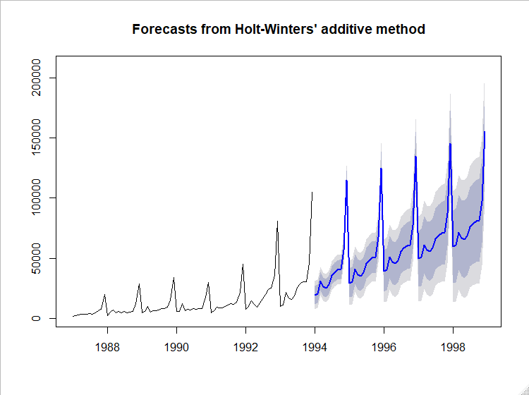

**2.1.2 Splitting data into Test/Train**

Creating a test set with 3 years and trains set of 4 years

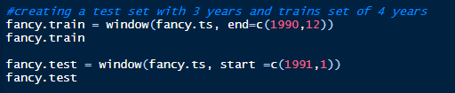

**Train Data**



**Test Data**



Creating basic holt winter’s model with 4 years of train data and using it to forecast for next 3 years and comparing the result.

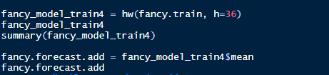

summary(fancy_model_train4)

Forecast method: Holt-Winters' additive method

Model Information:

Holt-Winters' additive method

Call:

hw(y = fancy.train, h = 36)

Smoothing parameters:

alpha = 2e-04

beta = 1e-04

gamma = 1e-04

Initial states:

l = 4773.1478

b = 155.4818

s = 18948.32 3509.07 -993.2272 -1773.537 -2458.433 -1890.759

-3084.518 -2398.866 -3401.075 1044.733 -3147.621 -4354.089

sigma: 1948.999

AIC AICc BIC

927.5622 947.9622 959.3726

Error measures:

ME RMSE MAE MPE MAPE MASE ACF1

Training set -111.4918 1591.351 1136.061 -1.197622 16.94519 0.5506224 0.1456358

Forecasts:

Point Forecast Lo 80 Hi 80 Lo 95 Hi 95

Jan 1991 8031.339 5533.596 10529.08 4211.370 11851.31

Feb 1991 9392.575 6894.832 11890.32 5572.607 13212.54

Mar 1991 13739.281 11241.537 16237.02 9919.312 17559.25

Apr 1991 9449.084 6951.340 11946.83 5629.115 13269.05

May 1991 10606.095 8108.351 13103.84 6786.126 14426.06

Jun 1991 10075.502 7577.758 12573.25 6255.532 13895.47

Jul 1991 11423.919 8926.174 13921.66 7603.947 15243.89

Aug 1991 11011.195 8513.449 13508.94 7191.222 14831.17

Sep 1991 11850.929 9353.182 14348.68 8030.954 15670.90

Oct 1991 12786.100 10288.351 15283.85 8966.122 16606.08

Nov 1991 17443.932 14946.181 19941.68 13623.952 21263.91

Dec 1991 33037.663 30539.910 35535.42 29217.679 36857.65

Jan 1992 9890.522 7392.766 12388.28 6070.534 13710.51

Feb 1992 11251.759 8754.001 13749.52 7431.767 15071.75

Mar 1992 15598.464 13100.702 18096.23 11778.467 19418.46

Apr 1992 11308.267 8810.502 13806.03 7488.265 15128.27

May 1992 12465.279 9967.509 14963.05 8645.270 16285.29

Jun 1992 11934.686 9436.912 14432.46 8114.670 15754.70

Jul 1992 13283.103 10785.324 15780.88 9463.079 17103.13

Aug 1992 12870.378 10372.594 15368.16 9050.346 16690.41

Sep 1992 13710.113 11212.322 16207.90 9890.072 17530.15

Oct 1992 14645.283 12147.486 17143.08 10825.232 18465.33

Nov 1992 19303.115 16805.311 21800.92 15483.053 23123.18

Dec 1992 34896.846 32399.033 37394.66 31076.771 38716.92

Jan 1993 11749.706 9251.883 14247.53 7929.616 15569.80

Feb 1993 13110.943 10613.111 15608.77 9290.839 16931.05

Mar 1993 17457.648 14959.806 19955.49 13637.528 21277.77

Apr 1993 13167.451 10669.598 15665.30 9347.315 16987.59

May 1993 14324.462 11826.598 16822.33 10504.309 18144.62

Jun 1993 13793.869 11295.993 16291.75 9973.697 17614.04

Jul 1993 15142.286 12644.397 17640.18 11322.094 18962.48

Aug 1993 14729.562 12231.658 17227.47 10909.348 18549.78

Sep 1993 15569.296 13071.378 18067.21 11749.060 19389.53

Oct 1993 16504.467 14006.532 19002.40 12684.206 20324.73

Nov 1993 21162.299 18664.348 23660.25 17342.013 24982.59

Dec 1993 36756.030 34258.061 39254.00 32935.717 40576.34

Below are predicted forecast for next 3 years of test data. Comparing it with actual test data.



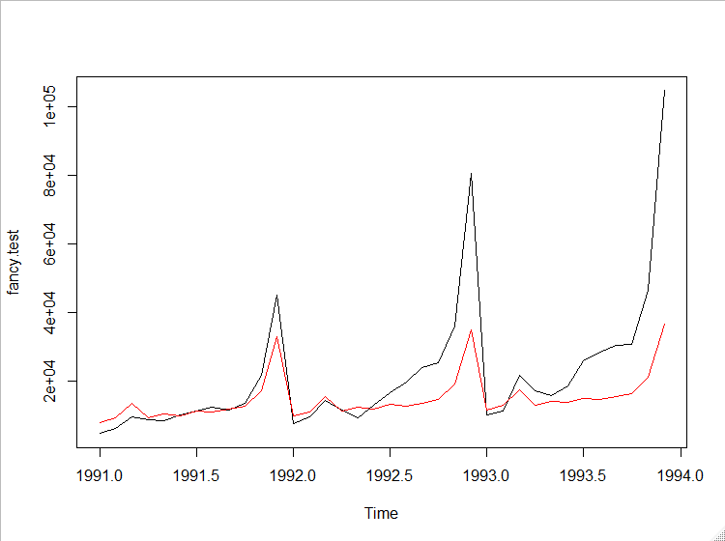



**The model is doing well in initial part of test years but it is not able to capture the spur of growth since later part of 1992 which suggests that multiplicative model would be better suited.**

Calculating the RMSE and MAPE of this model.

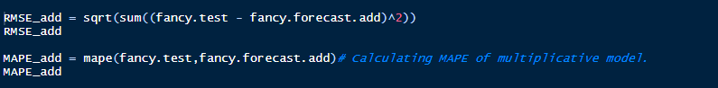

RMSE_add

[1] 94636.1

> MAPE_add

[1] 0.2804143

**We will now use the obtained smoothing parameters to predict for horizon of 5 years.**

Smoothing parameters:

alpha = 2e-04

beta = 1e-04

gamma = 1e-04

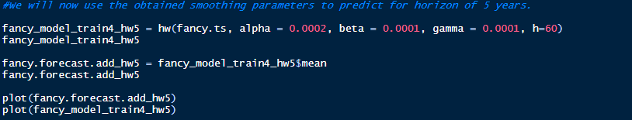

Below are the forecasted sales for next 5 years

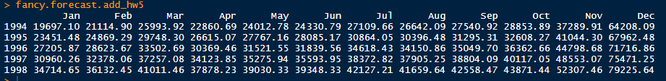

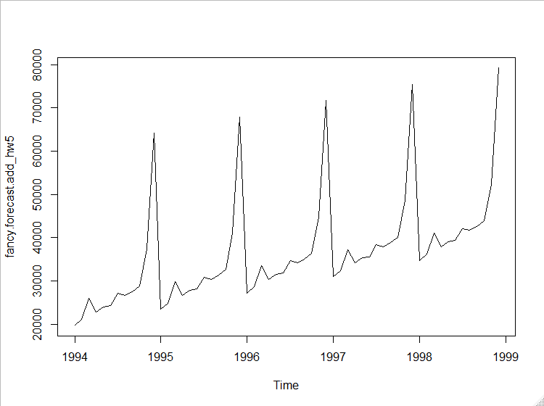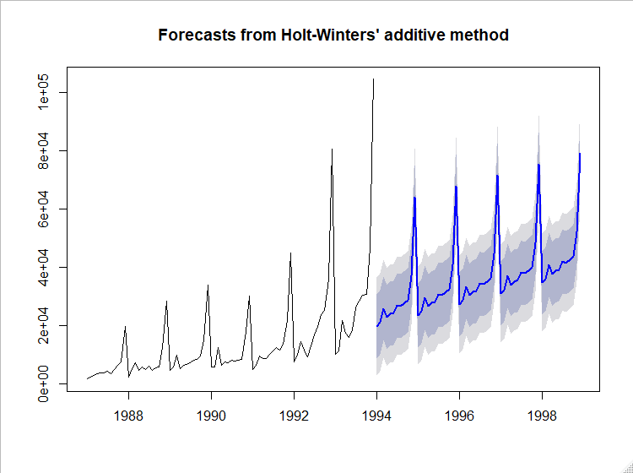

*As it is evident that additive model is not able to capture the increase in growth of sales for last 2 years, there is a need to look at the multiplicative model of holt winters as well which was suggested by initial analysis of time series as well.*

**2.1.3 Multiplicative model**



> summary(fancy_model_mult_hw5) # both RMSe and MAPE of multiplicative model suggests that this method fits better to the time series.

Forecast method: Holt-Winters' multiplicative method

Model Information:

Holt-Winters' multiplicative method

Call:

hw(y = fancy.ts, h = 60, seasonal = "m")

Smoothing parameters:

alpha = 0.4165

beta = 0.0243

gamma = 6e-04

Initial states:

l = 3957.9459

b = 186.0517

s = 3.176 1.4775 0.9811 0.9504 0.88 0.8064

0.6413 0.5762 0.6646 0.914 0.5146 0.4179

sigma: 0.1946

AIC AICc BIC

1661.938 1671.211 1703.262

Error measures:

ME RMSE MAE MPE MAPE MASE ACF1

Training set 111.4845 1573.73 1264.728 -1.223233 13.64245 0.2857896 0.1985004

Forecasts:

Point Forecast Lo 80 Hi 80 Lo 95 Hi 95

Jan 1994 14032.09 10533.0425 17531.14 8680.7577 19383.43

Feb 1994 17595.08 12799.7838 22390.38 10261.3060 24928.86

Mar 1994 31786.50 22391.2096 41181.78 17417.6456 46155.35

Apr 1994 23524.41 16030.9603 31017.86 12064.1678 34984.65

May 1994 20766.35 13675.1365 27857.55 9921.2771 31611.41

Jun 1994 23489.06 14929.1900 32048.93 10397.8691 36580.25

Jul 1994 30022.75 18392.0569 41653.45 12235.1382 47810.37

Aug 1994 33294.49 19629.5334 46959.45 12395.7408 54193.25

Sep 1994 36549.81 20704.3917 52395.22 12316.3359 60783.28

Oct 1994 38344.84 20832.0876 55857.60 11561.3954 65128.29

Nov 1994 58666.22 30506.2568 86826.19 15599.2703 101733.18

Dec 1994 128038.45 63584.2598 192492.64 29464.2738 226612.62

Jan 1995 17112.62 8095.0184 26130.22 3321.3881 30903.85

Feb 1995 21388.42 9612.1094 33164.74 3378.1050 39398.74

Mar 1995 38518.45 16394.8349 60642.07 4683.2996 72353.60

Apr 1995 28420.18 11417.0270 45423.32 2416.1041 54424.25

May 1995 25014.46 9446.9627 40581.95 1206.0295 48822.88

Jun 1995 28213.62 9971.8636 46455.37 315.2615 56111.98

Jul 1995 35961.96 11833.6395 60090.28 -939.1213 72863.04

Aug 1995 39774.13 12111.5701 67436.68 -2532.1020 82080.35

Sep 1995 43549.47 12184.3343 74914.61 -4419.3672 91518.31

Oct 1995 45572.94 11615.2375 79530.65 -6360.8855 97506.77

Nov 1995 69553.96 15981.5482 123126.37 -12377.9720 151485.89

Dec 1995 151438.98 30965.7317 271912.22 -32808.9517 335686.90

Jan 1996 20193.30 3613.3648 36773.23 -5163.5213 45550.12

Feb 1996 25181.95 3858.6956 46505.20 -7429.1535 57793.05

Mar 1996 45250.74 5760.8867 84740.59 -15143.7781 105645.26

Apr 1996 33316.18 3370.4391 63261.93 -12481.8806 79114.25

May 1996 29262.78 2188.5734 56336.99 -12143.6458 70669.21

Jun 1996 32938.42 1586.9306 64289.91 -15009.5453 80886.39

Jul 1996 41901.47 893.4745 82909.47 -20814.8472 104617.79

Aug 1996 46254.09 -267.5017 92775.69 -24894.5472 117402.74

Sep 1996 50549.51 -1675.6249 102774.64 -29321.9402 130420.96

Oct 1996 52801.43 -3209.2097 108812.06 -32859.4497 138462.30

Nov 1996 80442.27 -7133.8453 168018.40 -53493.8430 214378.39

Dec 1996 174840.78 -20433.2352 370114.79 -123805.0525 473486.60

Jan 1997 23274.14 -3383.5404 49931.83 -17495.2657 64043.55

Feb 1997 28975.69 -5046.0361 62997.41 -23056.0480 81007.42

Mar 1997 51983.40 -10564.1452 114530.95 -43674.8170 147641.62

Apr 1997 38212.47 -8888.5477 85313.49 -33822.3202 110247.26

May 1997 33511.35 -8790.5867 75813.28 -31183.8778 98206.57

Jun 1997 37663.49 -11011.0879 86338.07 -36777.8548 112104.84

Jul 1997 47841.33 -15439.8387 111122.49 -48938.8649 144621.52

Aug 1997 52734.45 -18639.1306 124108.02 -56422.0194 161890.91

Sep 1997 57549.96 -22129.7329 137229.65 -64309.6140 179409.53

Oct 1997 60030.35 -24971.0383 145031.73 -69968.0527 190028.74

Nov 1997 91331.25 -40897.2335 223559.74 -110894.7658 293557.27

Dec 1997 198244.01 -95155.0899 491643.10 -250471.1901 646959.20

Jan 1998 26355.18 -13510.1086 66220.47 -34613.5173 87323.88

Feb 1998 32769.66 -17879.4730 83418.79 -44691.5040 110230.82

Mar 1998 58716.49 -33997.8052 151430.79 -83077.7886 200510.77

Apr 1998 43109.07 -26419.1298 112637.26 -63225.1336 149443.27

May 1998 37760.19 -24434.7526 99955.12 -57358.7644 132879.14

Jun 1998 42388.87 -28900.9714 113678.72 -66639.5350 151417.28

Jul 1998 53781.57 -38559.2607 146122.41 -87441.5453 195004.69

Aug 1998 59215.22 -44564.1182 162994.56 -99501.5828 217932.03

Sep 1998 64550.87 -50909.4267 180011.18 -112030.4181 241132.17

Oct 1998 67259.75 -55506.0625 190025.56 -120494.3567 255013.85

Nov 1998 102220.97 -88147.5809 292589.51 -188922.6018 393364.53

Dec 1998 221648.83 -199463.2147 642760.88 -422386.4662 865684.13

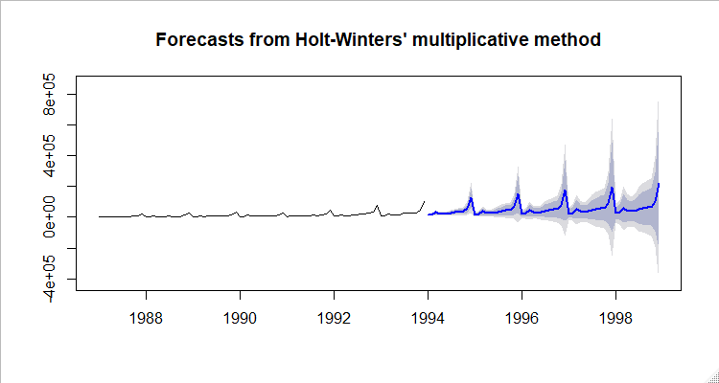 **Both RMSE and MAPE of multiplicative model suggest that this method fits better to the time series.**

**Splitting data into Test/Train**

Creating a test set with 2 years and train set of 5 years to take into account the recent explosion in sales. Taking a train of 4 years data will result in negative trends.



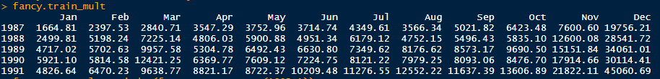





Building a model with 5 years of train data and forecasting. Comparing it with Test data

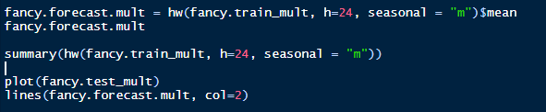



summary(hw(fancy.train_mult, h=24, seasonal = "m"))

Forecast method: Holt-Winters' multiplicative method

Model Information:

Holt-Winters' multiplicative method

Call:

hw(y = fancy.train_mult, h = 24, seasonal = "m")

Smoothing parameters:

alpha = 0.2178

beta = 0.0198

gamma = 1e-04

Initial states:

l = 4208.3295

b = 195.0312

s = 3.0591 1.5073 0.8884 0.7983 0.7929 0.7956

0.7177 0.7055 0.6299 1.0177 0.6002 0.4875

sigma: 0.1746

AIC AICc BIC

1124.164 1138.735 1159.767

Error measures:

ME RMSE MAE MPE MAPE MASE ACF1

Training set 59.63395 1206.105 934.3848 -1.783939 12.38556 0.3718488 0.05860524

Forecasts:

Point Forecast Lo 80 Hi 80 Lo 95 Hi 95

Jan 1992 7398.234 5743.181 9053.286 4867.049 9929.418

Feb 1992 9270.708 7139.314 11402.103 6011.022 12530.395

Mar 1992 15993.626 12207.158 19780.095 10202.723 21784.530

Apr 1992 10070.057 7610.864 12529.249 6309.046 13831.067

May 1992 11468.651 8575.632 14361.670 7044.161 15893.141

Jun 1992 11860.745 8766.828 14954.662 7129.008 16592.482

Jul 1992 13363.384 9755.654 16971.115 7845.837 18880.932

Aug 1992 13532.931 9749.475 17316.386 7746.634 19319.227

Sep 1992 13840.576 9831.948 17849.203 7709.909 19971.243

Oct 1992 15642.251 10947.952 20336.550 8462.941 22821.561

Nov 1992 26945.902 18566.544 35325.260 14130.779 39761.025

Dec 1992 55516.695 37629.287 73404.102 28160.266 82873.123

Jan 1993 8978.435 5981.692 11975.178 4395.312 13561.558

Feb 1993 11216.226 7339.318 15093.134 5287.007 17145.446

Mar 1993 19292.305 12389.036 26195.574 8734.666 29849.944

Apr 1993 12111.908 7627.214 16596.603 5253.160 18970.657

May 1993 13755.448 8487.473 19023.423 5698.776 21812.120

Jun 1993 14187.070 8570.187 19803.952 5596.789 22777.350

Jul 1993 15942.281 9420.563 22463.998 5968.175 25916.386

Aug 1993 16103.212 9300.198 22906.226 5698.900 26507.524

Sep 1993 16428.331 9264.850 23591.812 5472.732 27383.930

Oct 1993 18521.995 10190.497 26853.494 5780.068 31263.922

Nov 1993 31831.697 17069.103 46594.291 9254.258 54409.137

Dec 1993 65433.075 34162.769 96703.382 17609.268 113256.882

Under forecasting but better then additive model.

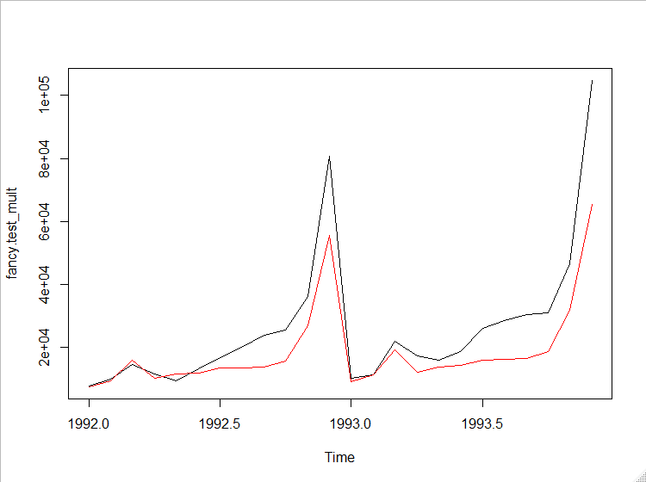

Comparing Test Vs Forecast sales value



Calculating RMSE and MAPE

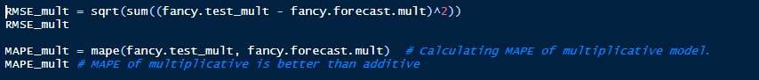

> RMSE_mult

[1] 58350.05

> MAPE_mult # MAPE of multiplicative is better than additive (0.2804143)

[1] 0.2430646

Both RMSE and MAPE are better for multiplicative model.

Smoothing parameters for current model

**alpha = 0.2178**

**beta = 0.0198**

**gamma = 1e-04 (0.0001)**

**Creating a hw model after optimizing the smoothening parameters**



Forecast based on modified smoothening parameters



Comparing Test Vs Forecast sales value



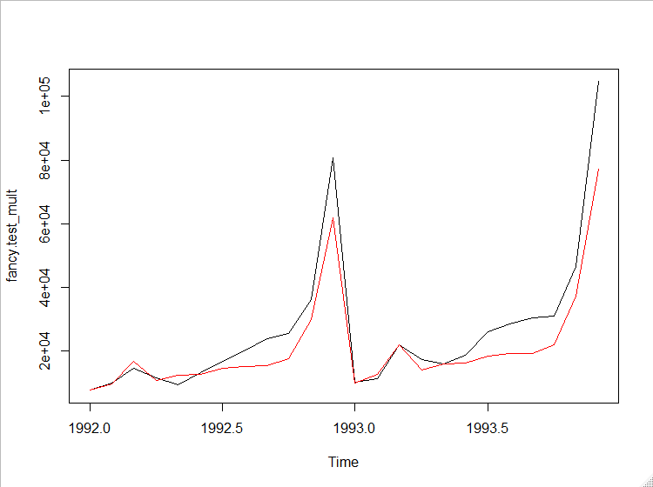

Calculating RMSE and MAPE for optimized model



> RMSE_opt

[1] 42130.14



> MAPE_mult

[1] 0.1771009

Both RMSE and MAPE is better in optimized model and also the forecast line is much fitted to test data when compared to basic multiplicative model.

**2.1.4 Building the final model**

Using the below smoothening parameters we will create a final model over entire time series dataset and use it to predict the forecast for next 5 years.

**alpha = 0.2178**

**beta = 0.04**

**gamma = 1e-04 (0.0001)**





